**Simple Factory**

The simple factory is not considered as a design pattern but rather a design practice programmers use for encapsulating objects.

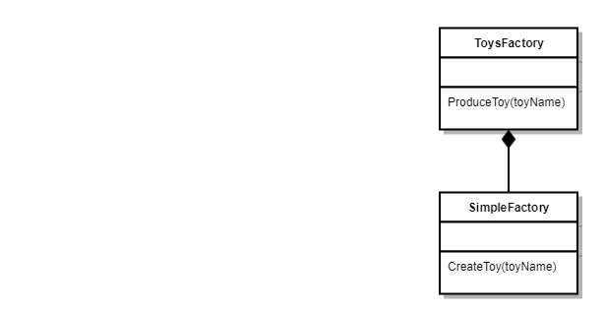

**Factory Method**

The factory method just like the simple factory is used for the creation of objects. But unlike the simple factory it use’s an abstract/interface class for object creation which allows you to create the objects without defining which class is to be instantiated. Which in turn allows any subclass of the abstract/interface class to instantiate the object.

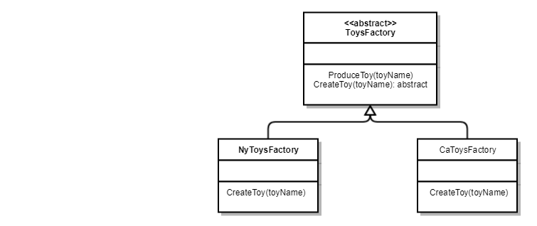

**Abstract Factory**

The abstract factory is similar to the factory pattern in most regards. But with an extra layer of abstraction which acts as a super factory aka “Factory of Factories”. It does this by delegating the responsibility of object instantiation to other object via composition.

